**Bullet Graph**

## Creating Bubble Chart

Using the Sample-superstore let's plan to find the size of profits for the respective sales figures in each sub-category. To achieve this objective we follow the below steps.

### Step-1

Drag and drop the dimension Sub-Category from the data pane into the column shelf.

### Step-2

Drag and drop the measures profit and sales to the rows shelf.

The below chart appears which shows the two measures as two separate categories of bar charts each representing the values for sub-categories.

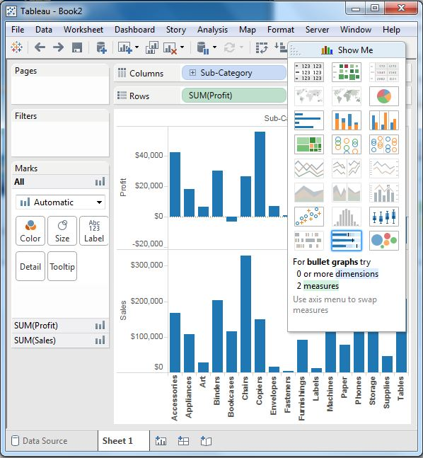

### Step-3

Drag the sales measure to the Marks card. Using show me choose the bullet graph option. The below chart shows the bullet graph.

